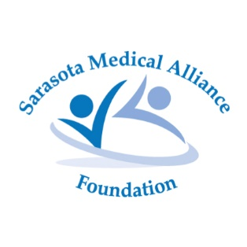

G.E.M.S. (Good Emergency Mother’s Substitute)

PERMISSION TO PHOTOGRAPH/Videotape

I, the undersigned, hereby consent for and on behalf of my child,

_____________________________________ (print name), who is under the age of 13 years old, to authorize Sarasota Medical Alliance Foundation, and any of its assigns and licensees, the use and reproduction of any and all photographs, videos of my child for educational, purposes for television, print or their website, or for the purpose of outreach promotion of its programs such as G.E.M.S.

By:_______________________________________________
Parent signature

Date: _______________

Print Name:___________________________________

www.donate-smaf.org

